Machine Learning Model Development
and Evaluation Report
Predicting Hotel Booking Cancellations with Random Forest

Prepared by: Abhiram Chander Sai Jandhyala
B.Tech Information Technology, JBIET, Hyderabad
Dataset: hotel_bookings_cleaned.csv
Date: August 2026

Executive Summary
This report documents the end-to-end development and evaluation of a machine learning model built to predict hotel booking cancellations using a cleaned hotel bookings dataset. A Random Forest Classifier was trained on 11 booking-level features, evaluated with standard classification metrics, validated using 5-fold cross-validation, and subsequently optimized through a grid search over key hyperparameters. The tuned model achieved an accuracy of 77.99%, a precision of 0.68 for cancellations, and a ROC AUC of 0.802, indicating strong discriminative ability between cancelled and non-cancelled bookings. Lead time and average daily rate (ADR) emerged as the two most influential predictors of cancellation behavior.

1. Introduction and Objective
Hotel booking cancellations create significant revenue and operational planning challenges for the hospitality industry. The objective of this project is to build a supervised classification model capable of predicting whether a given booking will be cancelled (is_canceled = 1) or honored (is_canceled = 0), using historical booking attributes. The resulting model can support proactive overbooking strategies, targeted retention outreach, and more accurate revenue forecasting.

2. Dataset Overview
Source file: hotel_bookings_cleaned.csv
Records: 87,203 bookings
Total columns: 36 (19 integer, 3 float, 14 categorical/object)
Target variable: is_canceled (binary: 0 = Not Cancelled, 1 = Cancelled)
The dataset had already been cleaned prior to modeling (no missing values across any of the 36 columns) and includes engineered fields such as total_guests, total_nights, is_family, and booking_status derived from the raw booking records.

2.1 Features Used for Modeling
A focused subset of 11 numeric, booking-behavior features was selected as model inputs, prioritizing signals directly tied to guest intent and booking flexibility rather than raw categorical identifiers:
- lead_time — days between booking date and arrival date
- adr — average daily rate
- total_guests — combined adults, children, and babies
- total_nights — total length of stay (weekend + week nights)
- previous_cancellations — guest's prior cancellation count
- previous_bookings_not_canceled — guest's prior honored bookings
- booking_changes — number of amendments made to the booking
- total_of_special_requests — count of special requests made
- required_car_parking_spaces — parking spaces requested
- days_in_waiting_list — days the booking spent on a waiting list
- is_repeated_guest — flag for returning guests

3. Methodology

3.1 Train-Test Split
The dataset was split into training and test sets using an 80/20 stratified split (stratified on is_canceled to preserve class balance), with a fixed random_state of 42 for reproducibility. This produced 69,762 training records and 17,441 test records.

3.2 Baseline Model
A Random Forest Classifier (scikit-learn's RandomForestClassifier, default hyperparameters, random_state=42) was first trained as a baseline to establish an initial performance benchmark before any tuning was applied.

3.3 Cross-Validation
To assess the stability of the baseline model's performance across different data splits, 5-fold cross-validation was performed on the full feature set (X, y) using accuracy as the scoring metric.

3.4 Hyperparameter Tuning
An exhaustive grid search (GridSearchCV) with 5-fold cross-validation was used to tune the Random Forest over the following parameter grid:
Hyperparameter | Values Searched
n_estimators | 100, 200, 300
max_depth | 10, 20, None
min_samples_split | 2, 5
min_samples_leaf | 1, 2
This produced 36 candidate parameter combinations, each evaluated across 5 folds (180 total model fits), optimizing for accuracy.

4. Baseline Model Evaluation
The untuned Random Forest baseline achieved the following results on the held-out 20% test set:
Metric | Score
Accuracy | 0.7619
Precision (Cancelled) | 0.5884
Recall (Cancelled) | 0.4498
F1 Score (Cancelled) | 0.5099
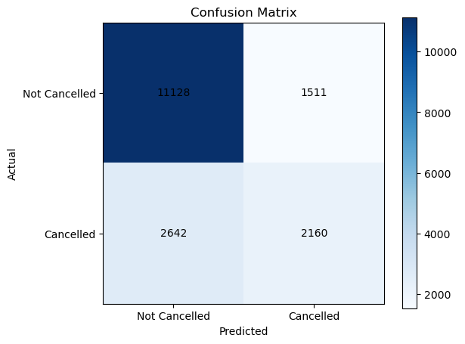
Figure 1. Confusion matrix — baseline Random Forest model on the test set.
The full classification report for the baseline model:
Class | Precision | Recall | F1-score | Support
0 (Not Cancelled) | 0.81 | 0.88 | 0.84 | 12,639
1 (Cancelled) | 0.59 | 0.45 | 0.51 | 4,802
Accuracy |  |  | 0.76 | 17,441
Macro avg | 0.70 | 0.67 | 0.68 | 17,441
Weighted avg | 0.75 | 0.76 | 0.75 | 17,441
The baseline model is noticeably stronger at identifying non-cancelled bookings (recall 0.88) than cancelled ones (recall 0.45), reflecting the class imbalance in the dataset (roughly 73% not-cancelled vs. 27% cancelled in the test split).

4.1 Cross-Validation Results
5-fold cross-validation on the baseline model produced the following per-fold accuracies:
Fold 1 | Fold 2 | Fold 3 | Fold 4 | Fold 5 | Mean
0.7359 | 0.7042 | 0.6691 | 0.6657 | 0.6721 | 0.6894
The mean cross-validation accuracy (0.689) is notably lower than the single train-test-split accuracy (0.762), and the fold-to-fold spread (0.666–0.736) indicates the baseline model's performance is somewhat sensitive to how the data is partitioned — a signal that motivated the subsequent hyperparameter tuning step.

5. Tuned Model — Hyperparameter Search Results
Grid search identified the following combination as optimal (highest mean cross-validated accuracy):
Parameter | Best Value
n_estimators | 300
max_depth | 20
min_samples_split | 2
min_samples_leaf | 2
Best cross-validated accuracy (grid search): 0.7774

5.1 Tuned Model Performance on the Test Set
Class | Precision | Recall | F1-score | Support
0 (Not Cancelled) | 0.80 | 0.93 | 0.86 | 12,639
1 (Cancelled) | 0.68 | 0.39 | 0.49 | 4,802
Accuracy |  |  | 0.78 | 17,441
Macro avg | 0.74 | 0.66 | 0.68 | 17,441
Weighted avg | 0.77 | 0.78 | 0.76 | 17,441
Test accuracy (tuned model): 0.7799
Compared with the baseline, tuning improved overall accuracy from 76.19% to 77.99% and raised precision on the cancelled class from 0.59 to 0.68 — meaning fewer false-positive cancellation predictions. However, recall on the cancelled class dropped slightly (0.45 → 0.39), showing the tuned model became more conservative: it is more confident when it does predict a cancellation, but it flags a smaller proportion of the true cancellations. This precision/recall trade-off should be weighed against business priorities (e.g., cost of a missed cancellation vs. cost of unnecessarily contacting a guest who was not going to cancel).

5.2 ROC Curve and AUC
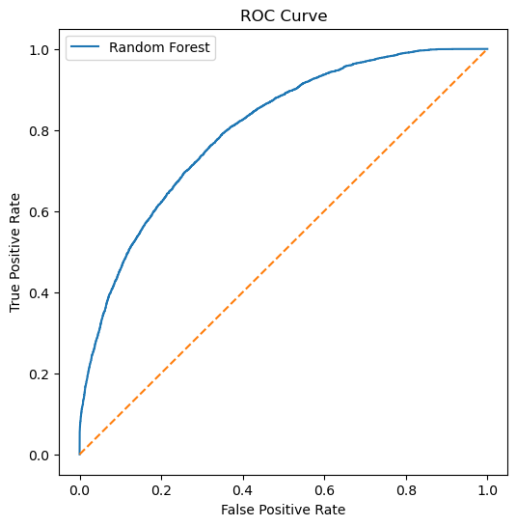
Figure 2. ROC curve — tuned Random Forest model.
ROC AUC: 0.8021
An AUC of 0.802 indicates the tuned model has strong ability to rank a randomly chosen cancelled booking above a randomly chosen non-cancelled one roughly 80% of the time — well above the 0.5 random-guess baseline, and generally considered 'good' discriminative performance for a binary classifier.

6. Feature Importance and Interpretation
Feature importances from the tuned Random Forest (Gini importance) reveal which booking attributes most strongly drive cancellation predictions:
Rank | Feature | Importance
1 | lead_time | 0.2943
2 | adr | 0.2656
3 | total_nights | 0.0868
4 | total_of_special_requests | 0.0858
5 | required_car_parking_spaces | 0.0804
6 | booking_changes | 0.0564
7 | previous_cancellations | 0.0549
8 | total_guests | 0.0445
9 | previous_bookings_not_canceled | 0.0169
10 | days_in_waiting_list | 0.0077
11 | is_repeated_guest | 0.0068
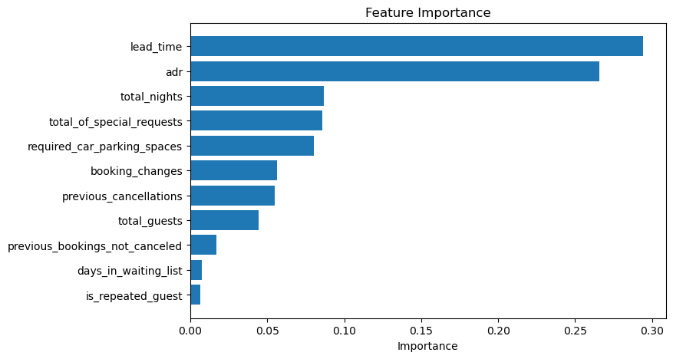
Figure 3. Ranked feature importances — tuned Random Forest model.
Interpretation of the top drivers:
- Lead time (29.4%) is the single strongest predictor — bookings made far in advance carry substantially higher cancellation risk, likely because guests have more time and opportunity to change plans.
- Average daily rate / adr (26.6%) is the second-strongest signal, suggesting price sensitivity plays a major role: bookings at unusually high or low rates relative to typical pricing are more prone to cancellation.
- Together, lead_time and adr account for over 56% of total model importance, meaning the remaining nine features contribute the other 44% collectively.
- Operational/behavioral signals — total_nights, total_of_special_requests, required_car_parking_spaces, and booking_changes — form a mid-tier group, indicating that guests more invested in the specifics of their stay (parking, requests, amendments) behave differently than casual bookers.
- is_repeated_guest and days_in_waiting_list contribute the least, suggesting loyalty status and waitlist duration are comparatively weak standalone predictors in this feature set.

7. Conclusion and Recommendations
The tuned Random Forest model provides a reliable, moderately strong predictor of hotel booking cancellations, improving on the untuned baseline across accuracy, precision, and ROC AUC. With an AUC of 0.80 and 78% overall accuracy, the model is well-suited for prioritizing which bookings warrant proactive intervention (e.g., confirmation reminders or flexible-rate offers) rather than for fully automated decision-making, given its relatively lower recall (0.39) on the cancellation class.
Recommendations for future iterations:
- Address class imbalance directly (e.g., class_weight='balanced', SMOTE, or threshold tuning) to improve recall on cancellations without excessively sacrificing precision.
- Incorporate categorical features (e.g., market_segment, deposit_type, distribution_channel, customer_type) via encoding, since these were excluded from the current numeric-only feature set but plausibly carry cancellation signal.
- Benchmark against gradient boosting methods (XGBoost, LightGBM), which often outperform Random Forest on tabular booking data.
- Re-evaluate the optimal decision threshold (rather than the default 0.5) based on the relative business cost of false positives vs. false negatives.

8. Appendix — Tools and Environment
Language / libraries: Python, pandas, numpy, matplotlib, scikit-learn
Model: sklearn.ensemble.RandomForestClassifier
Tuning method: sklearn.model_selection.GridSearchCV (5-fold CV, scoring='accuracy', n_jobs=-1)
Random seed: 42 (used throughout for reproducibility)

